Question 2 Test

For a transformation: Rotation Matrix along z

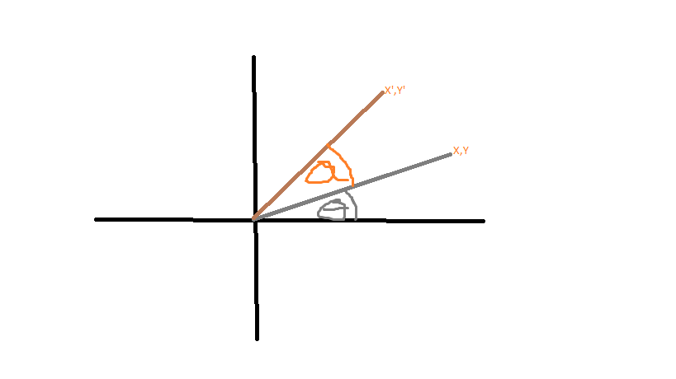

We can represent the original co-ordinates of the system as a vector